Sharky’s Woodfired Mexican Grill
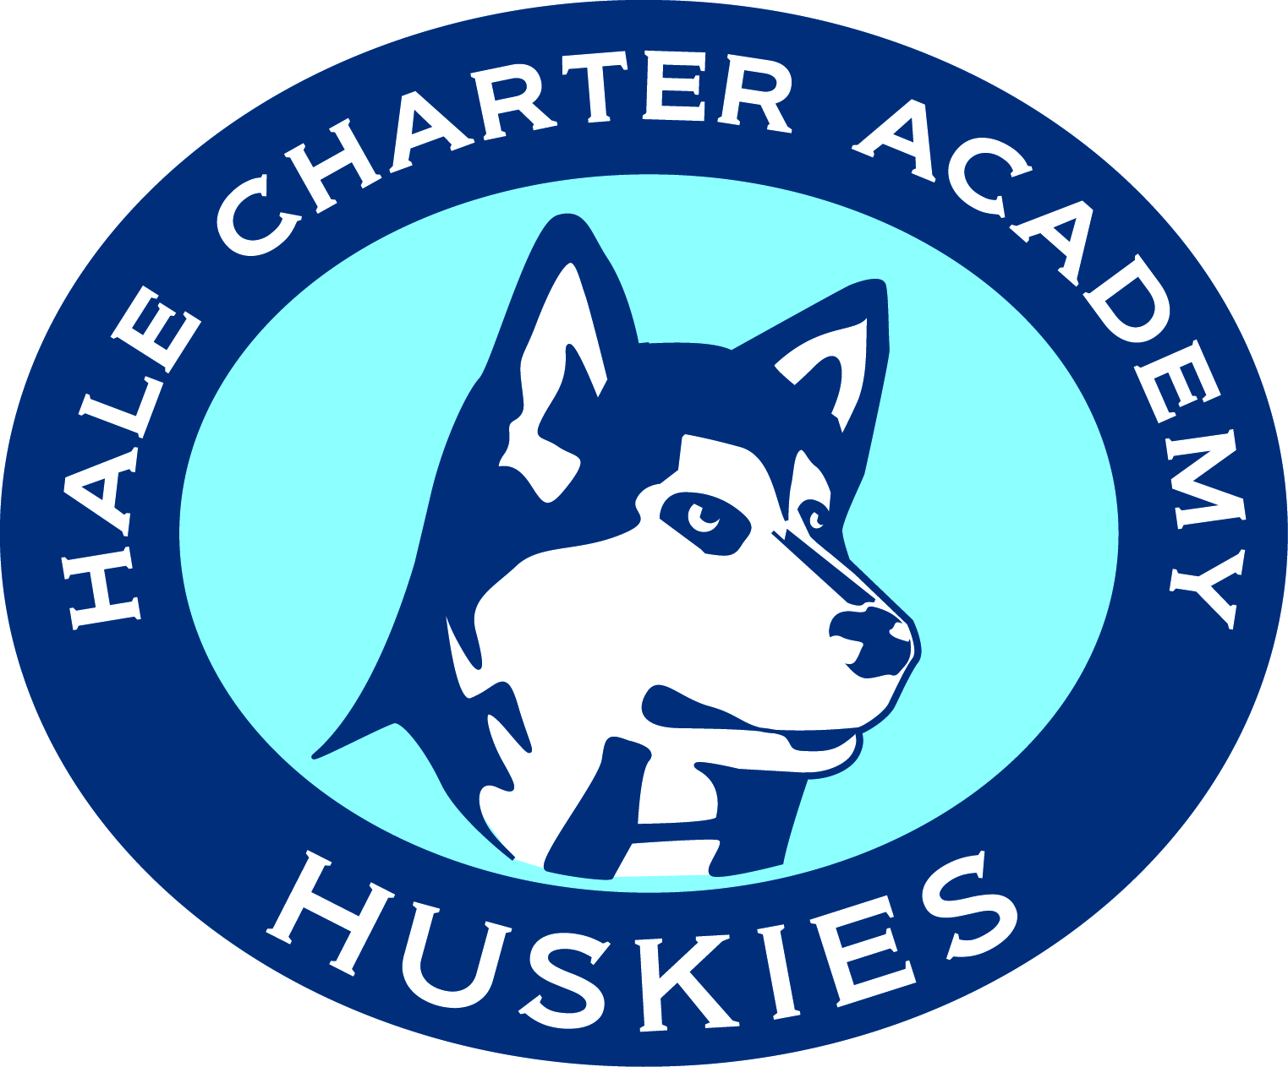
Fundraiser

Enjoy KILLER food with your family and friends
AND raise money for your school.
All you need to do is bring this flyer for dinner
on the scheduled date to the location listed below.

20% of net sales will benefit
Hale Charter Academy


Sharky’s Woodfired Mexican Grill Location:

Woodland Hills
6219 Erwin St. Woodland Hills
Corner of Topanga Cyn/Erwin/The Office Depot Center
Call Ahead/Take-out:
818-887-6963

WHEN: FEBRUARY 4TH, 2014
FROM: 11:00am-9:00pm

Thanks for your support.
We look forward to seeing you there!
Please Remember:
Present this flyer when ordering OR picking up your phone-ahead order so that Hale Charter Academy may receive the 20%

Not valid with any other discounts or offers. Valid on the date and location. Eat in or take out. Flyer is not valid if distributed outside the restaurant.

Sharky’s Woodfired Mexican Grill
Fundraising

Enjoy KILLER food with your family and friends
AND raise money for your school.
All you need to do is bring this flyer for dinner
on the scheduled date to the location listed below.

20% of net sales will benefit
Hale Charter Academy

Sharky’s Woodfired Mexican Grill Location:

Woodland Hills
6219 Erwin St. Woodland Hills
Corner of Topanga Cyn/Erwin/The Office Depot Center
Call Ahead/Take-out:
818-887-6963

WHEN: FEBRUARY 4TH, 2014
FROM: 11:00am-9:00pm

Thanks for your support.
We look forward to seeing you there!
Please Remember:
Present this flyer when ordering OR picking up your phone-ahead order so that Hale Charter Academy may receive the 20%

Not valid with any other discounts or offers. Valid on the date and location. Eat in or take out. Flyer is not valid if distributed outside the restaurant.

